media attention

print publications

BLINDED BY YOUR GRACE – FRANCE – JUne 2026
International contemporary photography artist book exploring gender, risk, and storm chasing – contributing photographer – multiple images featured

STORM: Chasing nature’s wildest weather - oct 2025
Book by Hank Schyma – multiple images featured

significant tornadoes 1974-2022 – NOV 2023
The Definitive Book on U.S. tornadoes – multiple images featured

professional photographer magazine – may 2023
“Alive With Character” Feature story on studio and portrait work with multi-spread article interview and photos

cOSMOPOLITAN MAGAZINE – MAY 2022
“Chase Season” Article interview and photos

the observer magazine – uk – Feb 2021
“In the Eye of the Storm” Article interview and lead photo

creative nonfiction magazine – winter 2016
“Capturing the Storm” – biographical article by Laura Jones

milwaukee magazine – june 2014
“And the Thunder Rolls” – Lead photo and interview

welt der wunder magazine - germany – sept 2013
“What to do when Monsters Storm?” – Lead photo

the london telegraph - uk – april 2013
“On the Road With the Storm Chasers” – Lead and feature photos

film appearances

“twisters” – july 2024
Storm Chaser / Self – Background – Universal Studios motion picture

“storm chasing: the anthology” – 2016
Self – Documentary film by Blake Naftel

“storm assist 2014”
Narrator – DVD/Blu-ray charity production

“the road to el reno” – 2013
Self – Documentary short film by Tony Laubach

television appearances

“earthstorm” – october 2022
NETFLIX original docuseries

nbc top story – october 2022
“Female Storm Chasers Pursue Passion…” Featured interview and photographs

national geographic explorer – february 2019
Episode “Ancient Fighting Arts…” Short feature on Dr. Anton Seimon’s research project

web features and videos

shepherd express – MARCH 2025
“Jennifer Brindley Portrait Will Capture Your Essence” – HerStory Feature Article

ONMILWAUKEE – MARCH 2023
“Jennifer Brindley Portrait develops professional, personal brands”

nongirly – october 2021
“A Photographer’s Unique Path into Storm Chasing” and “How to Become a Storm Chaser with Jennifer Brindley” Videos and articles

washington post – june 2019
“This beastly tornado left behind captivating images and an incredible set of data” – Lead photo and two story images

SIERRA MAGAZINE – OCTOBER 2017
“Why do People Become Storm Chasers?” – Featured image and interview

OnMilwaukee – May 2013
“Local Storm Chasers Share Insights and Close Calls” – Featured images and interview

podcast interviews

Storm before the calm – spring 2025
S1E4 – Jennifer Brindley Ubl

girls who chase – january 2021
S1E4 – Jennifer Brindley Ubl: Creating a Life You Love

outside magazine– may 2021
“When the Tornado Chased the Storm Chaser”

chaserchat– march 2021
Featured Interview

milwaukee momcast – january 2020
Ep. 09 “Why Moms Need to Exist in Photos”

finding bliss podcast – august 2019
Ep. 054“Overcoming Fear of Failure and Comparisons”

new hampshire public radio [npr] – may 2018
“Ride or Die” story by Jimmy Gutierrez

storm front freaks – may 2018
Ep. 52 “Women in Chasing”

the ghost train podcast
“The Burning Passion” – January 2015
“Mother Nature, She Awakens” – April 2015

panel appearances

girls who chase – 2024
“Spring Training” veteran storm chasers panel sponsored by the American Meteorological Society through MetEd / COMET.

american meteorological society – 2024
“So, You Want to Be a Storm Chaser” Weatherband webinar

madison professional photographers – 2019
“Photography Panel Extraordinaire” Photography expert panel

educational

virtual / streaming

girls who chase – Nov/Dec 2026
“Capture Awe” educational instructor - sponsored by the American Meteorological Society through MetEd / COMET.

STORM PHOTOS OF the YEAR “STORMIES” – 2024-current

International storm photography competition - Judge

spring training – march 2024
GIRLS WHO CHASE Storm Chasing Educational Program: “Storm Structure / Storm Spotting Basics” and “Positioning for Safe and Successful Chasing” both co-presented with Skip Talbot

photo midwest education – feb 2023
“Third Thursday” educational presentation

conference presentations

natiOnal storm chasers summit – feb 2023
GIRLS WHO CHASE “Girls Who Chase – One Year Later” Co-presented with Jennifer Walton

indiana storm chasers convention
Presentations in 2015, 2016 and 2022

minnesota severe storms conference
Presentation in 2018

nat’l tropical severe weather conference
Presentation in 2014 co-presented with Skip Talbot

SCHOOL / CLASSROOM presentations

BIG IDEAS LEARNING – JUNE 2023
“Career Explorations: Storm Chaser” K-8 textbook pairing educational video in partnership with National Geographic Learning

grace lutheran oak creek – March 2014
“Storm Chasing and Tornadoes” – 3rd Grade Class

HIGHLAND COMMUNITY SCHOOL – May 2016
“Storm Chasing and Tornadoes” – 1st – 3rd Grade Class

projects

research

tornado science research 2016-2022
Multi-year tornado research project with Skip Talbot, Dr. Anton Seimon, Dr. Tracie Seimon, Dr. John Allen and Hank Schyma

media

“storm chaser” film 2018
Consultant and Artist / Art contributor for short film directed by Gretl Clagget

“EXTREME WEATHER” IMAX FILM 2014-2015
Support crew and behind-the-scenes photographer for armored TIV and Doghouse chase vehicles

CHARITY / community / VOLUNTEER WORK

ignite the spirit mke – 2018-2019, 2021-2023
Annual Milwaukee Firefighter’s Charity Calendar photographer

west allis block grant committee member – 2025-current

The Block Grant Committee oversees and makes suggestions for the use of Federal Community Development Block Grant funds received by the City of West Allis.

storm assist - 2012
Co-founded 501c3 non-profit organization to raise money for tornado victims
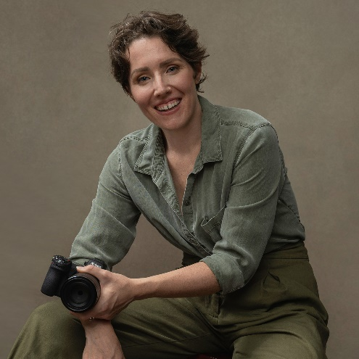

JENNIFER

BRINDLEY UBL
  - PORTRAIT PHOTOGRAPHER
  - EDUCATOR
  - STORM CHASER

PROFILE
Professional Portrait Photographer operating a studio for 18 years, specializing in Contemporary Portrait and Personal Branding. In the spring months, focus turns to storm chasing in the central United States. One of the most well-known female storm chasers in the world. Highly sought-after educator in photography, storm chasing and meteorological spaces.

CONTACT
info@jenniferbrindley.com
jenniferbrindley.com
faceofastorm.com
(414)-217-9014
1521 S. 79th St.
West Allis, WI 53214

ACTIVITIES AND INTERESTS
Fashion • Art • Film
Veganism • Photography
Social Justice • Gender Equality

career highlights

historical tornadoes

documented
-Largest tornado on record 5/31/13
El Reno, OK (2.6 miles wide + 301mph top wind speeds)
-Fastest tornado on record 6/16/14 Pilger, NE (94.6mph forward moving velocity)

stats
-Total number of tornadoes documented: 58
-First tornado: 2007

professional certifications and accreditations

-Master Photographer
The Portrait Masters International 2020

-associate photographer
Icon International Photography Awards 2025

-associate photographer
Wedding and Portrait Photographers International (WPPI) 2015

